MECC 2026 SPECIAL SESSION • HANDS-ON ACTIVITY  Tune the Pendulum  Explore P, PI, PD, and PID control through hands-on gain tuning |  |  |  | 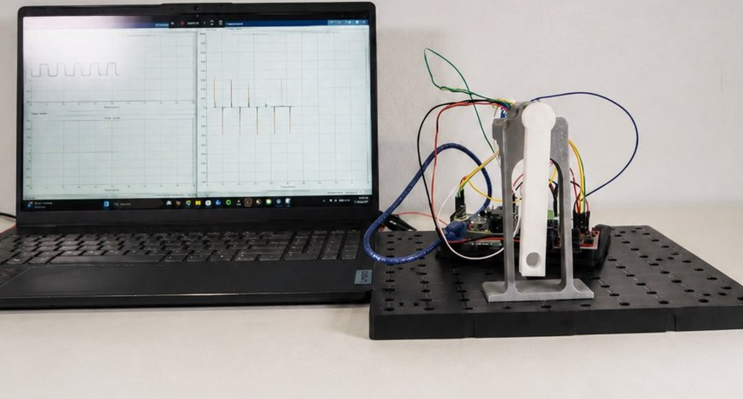
 | 15 MINUTES | WORK IN PAIRS | YOUR DESIGN VARIABLES: K_{p}, K_{i}, K_{d}
Why? A controller’s performance depends strongly on how it is tuned. In this activity, you will change Kp, Ki, and Kd on a real pendulum, observe how each term changes the measured response, and use your observations to design a controller that tracks the target.
By the end you will be able to:
- Predict how changes in K_{p}, K_{i}, and K_{d} will affect the pendulum response.
- Compare your prediction with measured overshoot, steady-state error, and oscillation.
- Design and justify a set of PID gains that produces an acceptable tracking response.
MEET THE MODEL: WHAT YOU WILL USE
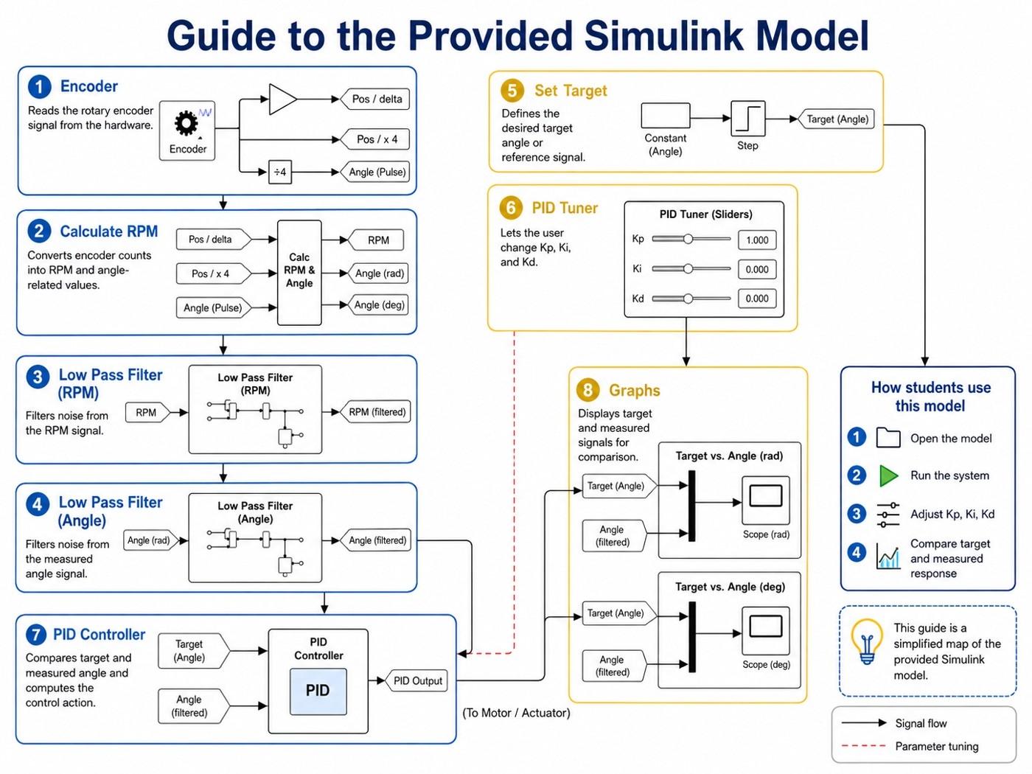  Guide to the provided Simulink model. The gold blocks (5, 6, 8) are the ones you use. | The model is already built. Blocks 1–4 and 7 read the encoder, filter the signals, and run the PID controller, so leave them alone.  5 SET TARGET  Set the two targets to +45° and −45° with a 2 s hold at each (period 4 s).  6 PID TUNER  Move the sliders or type values for K_{p}, K_{i}, K_{d}. Start with Ki = 0 and Kd = 0.  8 GRAPHS  Open the Target vs. Angle (deg) scope. Read overshoot and steady-state error here.  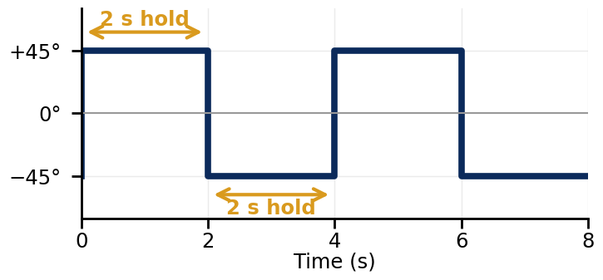  Target: +45° for 2 s, then −45° for 2 s
REFERENCE: HOW EACH PID GAIN AFFECTS THE RESPONSE
Increase this gain | Rise time | Overshoot | Settling time | Steady-state error | Practical note
K_{p} | ▼ Decreases | ▲ Increases | ● Small change | ▼ Decreases | Faster response; too large causes oscillation and instability.
K_{i} | ▼ Decreases | ▲ Increases | ▲ Increases | ✔ Eliminates | Removes steady offset; too large causes overshoot and slow oscillation.
K_{d} | ● Small change | ▼ Decreases | ▼ Decreases | ● No change | Adds damping; too large amplifies encoder noise and makes the motor buzz.
▼ helps ▲ hurts ● little effect. These are typical trends when one gain changes and the others stay fixed. The gains interact, so use them to make predictions, not as guarantees.

GROUND RULES
- Change one gain at a time so you can link each change in the response to its cause.
- Predict first. Write your expectation in the Observations column, then run and compare.
- Safety: keep the supply at or below 12 V. If the pendulum oscillates violently, stop the model and lower the last gain you raised.

RECORD YOUR DESIGN ATTEMPTS
Starting gains from your facilitator: K_{p} = ______ K_{i} = ______ K_{d} = ______
How to measure: Overshoot (%) = peak beyond the target ÷ 90° × 100 (the step between targets is 90°). Steady-state error (°) = target minus measured angle at the end of the 2 s hold.

1 P CONTROLLER
Set Ki = 0 and Kd = 0. Try a small, a medium, and a large Kp.
Trial | K_{p} | Overshoot (%) | Steady-state error (°) | Observations: prediction, rise, oscillation, noise
1
2
3
Reflect: How did increasing K_{p} change overshoot and steady-state error? __________________________________

2 PI CONTROLLER
Keep your best Kp. Add Ki and increase it gradually.
Trial | K_{p} | K_{i} | Overshoot (%) | Steady-state error (°) | Observations: prediction, rise, oscillation, noise
1
2
3
Reflect: What did K_{i} do to steady-state error, and what did it cost? __________________________________

3 PD CONTROLLER
Set Ki = 0. Keep your best Kp. Add Kd and increase it gradually.
Trial | K_{p} | K_{d} | Overshoot (%) | Steady-state error (°) | Observations: prediction, rise, oscillation, noise
1
2
3
Reflect: What did K_{d} do to overshoot and oscillation? Did you notice noise? __________________________________

4 PID CONTROLLER
Use all three gains to get your best overall response. Aim for the targets below.
Trial | K_{p} | K_{i} | K_{d} | Overshoot (%) | Steady-state error (°) | Observations: prediction, rise, oscillation, noise
1
2
3
4
Targets: overshoot below 10%, steady-state error below 2°, and no sustained oscillation at either hold.
My final gains: K_{p} = ________ K_{i} = ________ K_{d} = ________
WRAP-UP: DISCUSS WITH YOUR PARTNER (1 MIN)
1 Which gain changed the response the most? What evidence in your tables supports this?
2 Describe one tradeoff you saw, where improving one characteristic made another worse.
3 How would you use prediction, observation, and evidence to tune a different system?

